**Department of Cottage and Small Industry**

* **Application for cottage & small-scale industry license.**
* **Application for Renewal of cottage & small-scale industry license.**
* **Application for Cancellation of cottage & small-scale industry license.**
* **Application for duplication of cottage & small-scale industry license.**

**Electronic Government to Citizen Service Delivery System- Upgradation**

Version 1.0

**Submitted By:**



**NGN Technologies Ltd.**

Software Requirement Specification Document



|  |  |  |
| --- | --- | --- |
| **DOCUMENT RELEASE NOTICE** | | |
| **Document Title** | **:** | **Electronic Government to Citizen Service Delivery System- Upgradation** |
| **Release (Number)** | : | 1.0 |
| **Date of Release** | : |  |
| **Department** | : | Dept. of Cottage and Small Scale Industry |
| **Process Owner(s)** | : | Mr. Muna Mukhia |
| **Author(s) / Date** | : | Tshewang Tenzin |
| **Reviewer(s) / Date** | : | Mr. Sonam Chedup |
| **Approved by / Date** | : |  |

|  |  |  |  |
| --- | --- | --- | --- |
| Document Acceptance | | | |
| **Process Owner** | **Designation** | **Agency** | **Sign Off** |
| Mr. Muna Mukhia | Head | Dept. of Cottage and Small Scale Industry |  |

Table of Contents

1 Introduction 5

1.1 Purpose 5

1.2 Scope 5

1.3 Glossary 6

1.4 References 6

2 Service Specification 7

2.1.1 Application for cottage & small scale industry license 7

2.1.2 Application for Renewal/Duplicate/Cancellation of cottage & small scale industry license 9

3 Use Cases 10

Use Case# 3.1 Submission of License Application 10

3.1.1 Description 10

3.1.2 Actor(s) 11

3.1.3 Detailed process flow 11

Use Case# 3.2: Application for Renewal/Duplicate/Cancellation

of cottage & small scale industry license 24

3.2.1 Description 24

3.2.2 Actor(s) 25

3.2.3 Detailed process flow 25

4 Reports 43

4.1 Detail Report 43

4.2 Figure Report 44

# Introduction

The Department of Cottage and Small Scale Industry, Royal Government of Bhutan, hereby referred to as DCSI, intends to undertake upgradation of existing system built under the G2C phase II. The existing services automation was done in order to achieve an overall improvement in service delivery and other satisfaction for the citizens.

This document describes the detailed work flow structure of all services of DCSI and detailed process flow, Actors, envisaged benefits and screen captures from the indicative prototype. This document will serve as the main contention for developing the online service delivery framework for the said agency and will form the basis on which the actual system will be designed and implemented.

## 1.1 Purpose

This Software Requirement Specification provides the design details for the existing system and the TO-BE system. It will explain the AS-IS and TO-BE process of all services delivery work flow, features of the system and the interfaces of the system under DCSI. This document is intended for both the stakeholders and the developers of the system.

This will also serve as a reference document for the maintenance team who will be responsible for the maintenance of the system after the final release of the product.

## 1.2 Scope

This document contains the complete description and design for all services under DCSI. This assignment is to upgrade, design, develop and deploy web-based service delivery and processes includes:

* Submission of application by applicants.
* Verification of the application by Data Manager in Regional Office.
* Approval of application by Regional Director in RTIO.

## 1.3 Glossary

|  |  |
| --- | --- |
| SRS | Software Requirement Specification |
| G2C | Government to Citizen |
| ICT | Information Communication Technology |
| UAT | User Acceptance Test |
| DCSI | Department of Cottage and Small Industry |
| RTIO | Regional Trade and Industry Office |
| RD | Regional Director |
| CC | Community Centre |
| CID | Citizenship Identity Card |
| SCC | Security Clearance Certificate |

## 1.4 References

* Existing Software Requirement Specifications documents
* Brainstorming session held during the System study period
* Documents supplied by G2C and MoEA during the course of requirement study

# Service Specification

###### 2.1 Process Flow

### 2.1.1 Application for cottage & small scale industry license

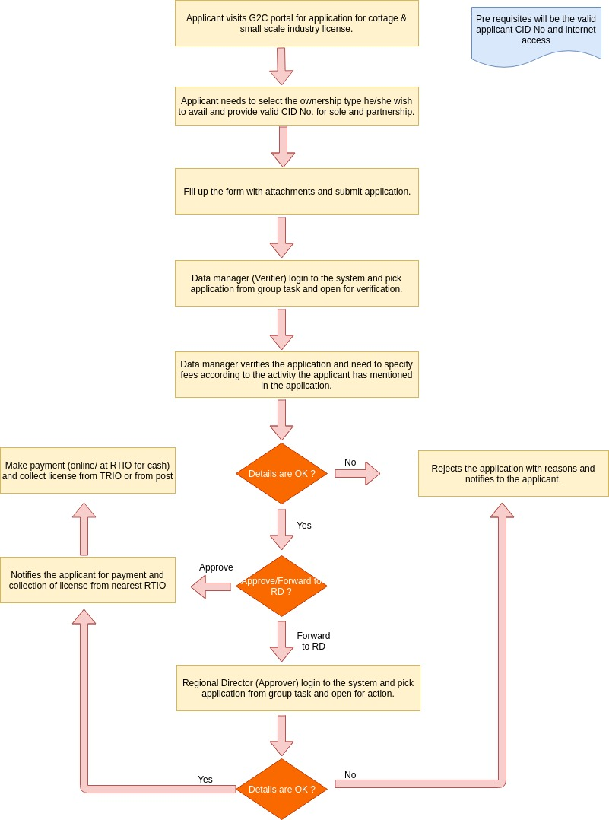

The process flow shown above depicts the AS-IS and TO-BE scenario of **Application for Cottage and Small Scale Industry License**. It has mainly three use-cases that includes (i) Application submission for License, (ii) Verification of application by Data Manager, RTIO, (iii) Approval of the same by RD.

Functionality wise there will be the following parts–

1. Apply for License- will be made open to public where applicant can apply for license without having to log-in to the system.
2. Check the status of application- is exposed to the Common G2C Service Gateway without any log-in i.e. accessible to all.
3. Verification of applications by Data Manager, RTIO- only accessed by Data Manager from RTIO internally after having login to the system.
4. Approve applications by RD- only accessed by Data Manager from RTIO internally after having login to the system.

### 2.1.2 Application for Renewal/Duplicate/Cancellation of cottage & small scale industry license

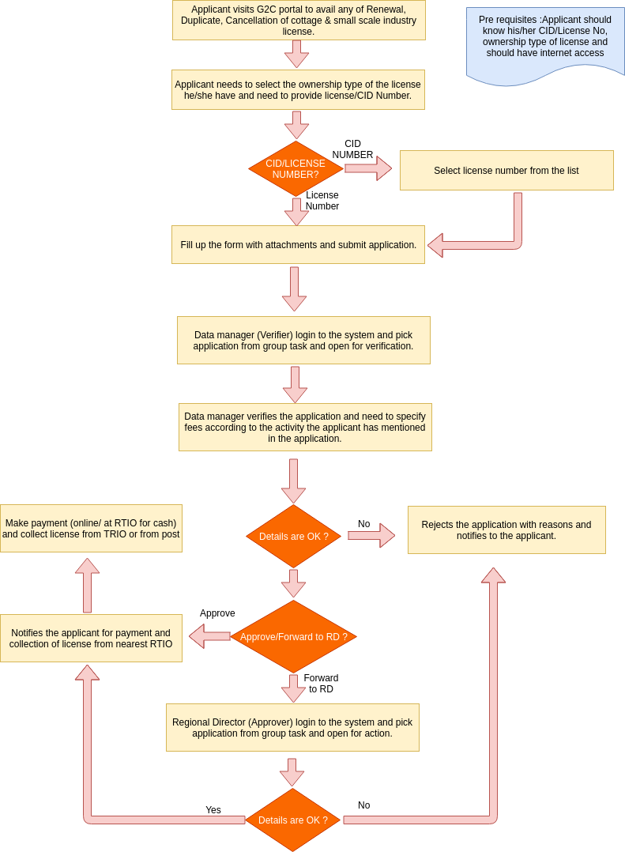

The process flow shown above depicts the AS-IS and TO-BE scenario of **Application for Renewal/Duplicate/Cancellation of Cottage and Small Scale Industry License**. It has mainly three use-cases that includes (i) Application submission for Renewal/Duplicate/Cancellation of License, (ii) Verification of application by Data Manager, RTIO, (iii) Approval of the same by RD.

Functionality wise there will be the following parts–

1. Apply for any services mentioned above that applicant wish to- will be made open to public where applicant can apply without having to log-in to the system.
2. Check the status of application- is exposed to the Common G2C Service Gateway without any log-in i.e. accessible to all.
3. Verification of applications by Data Manager, RTIO- only accessed by Data Manager from RTIO internally after having login to the system.
4. Approve applications by RD- only accessed by Data Manager from RTIO internally after having login to the system.

# **Use Cases**

### Use Case# 3.1 Submission of License Application

### 3.1.1 Description

This use case is the starting point of the application for cottage & small scale industry license service. The applicant submits online license application with some documents attached. The applicants can also visit nearest RTIO to apply on behalf of them, if they are not aware of the online system. The ownership can be of 4 major types: Sole Proprietorship/ Partnership/ Company / Others. If the applicant visits RTIO office, then the online form will be filled up by the responsible persons and user gets the acknowledgement receipt with unique Application ID and sms notification will be send to applicant on submitting the application details. Detail description is in the Basic Flow section. This use case translates the process described in AS-IS and TO-BE of the Process Flow Diagram.

### 3.1.2 Actor(s)

Citizens of Bhutan, Data Managers, RD.

### 3.1.3 Detailed process flow

* Applicant can visit to G2C portal to avail application for cottage & small scale industry license.
* Click on the link called application for cottage & small scale industry license under the business services. Applicant will be redirected to the page where they need to select the ownership of license.
* For sole proprietorship and partnership, applicant need to provide CID on which the system will connect to Census database and fetch the personnel details from there.
* Rest of the details in the form need to be filled by the applicant and submit the details to RTIO for verification and approval.
* System will generate the random Strings(application number) after applicant click on the submit button.
* Now application will be there in the Data manager (verifier) task-list for further action. Mean while applicant may check their application status from track application from the portal.
* To take further action on this application, Data manager need to login to the system. He/She need to select the application from the group task and assign to my task and open the application for verification.
* Data manager will review the application details and verifies all the document attached along with the application. He/she may approve, reject or forward this application to RD mentioning the classification, sub classification and application fees.
* If data manager rejects the application, then the applicant will receive the sms notification with the reason for rejecting and if he/she approves, then applicant will again receive message with the payment information. If he/she forwards to RD, then application will be reached the the Approver’s group task list.
* Data manager will then get respective acknowledgement for taking action.
* Regional director will login to the system and claim the application from group task and opens to take further action. He/she may either reject or approve the application and accordingly the applicant will receive the sms notification and he/she will be redirected to acknowledgement page.
* If the application is approved form data manager or RD, then applicant need to make payment either from online payment or visiting to the RTIO(off-line payment).
* For the online payment, applicant need to visit G2C online payment from portal or he/she will be redirected from the link mentioned in sms notification. On pressing go button, system will display payment details for availing that service and need to select banks after pressing pay now button. Applicant need to have any one of the bank account with their mobile number registered with that bank. OTP will be send to the mobile of applicant if bank account and mobile are valid. Applicant needs to use OPT to pay the service fees and will be redirected to the payment receive.
* To do offline payment, applicant needs to visit RTIO with cash. Data manager will login to the system and click on print license link to update payment in the system. To do that he/she need to select update payment tab and region where the application belongs, where by the application list will be displayed and need to select that application from the list and update details.
* Once payment is done, a unique license number will be generated by system. This license will be printed from region and distributed to applicant via post or applicant can visit to RTIO office to collect themself.
* In above processes, all of the actors can track the application at any time.

**3.1.4 Alternative Flows (if any)**

* Applicant can visit to nearest RTIO for the application of cottage & small scale industry license.
* Data manager from RTIO will login to the system. Select the service called Issuance of license under Create new application. He/She will be redirected to ‘select ownership type’, the applicant wish to take license.
* For sole proprietorship and partnership, he/she need to provide applicant’s CID on which the system will connect to Census database and fetch the personnel details from there.
* He/she needs to fill up rest of the details on behalf of applicant and submit the details for further approval by RD.
* System will generate the random Strings(application number) after applicant click on the submit button.
* Regional director will login to the system and claim the application from group task and opens to take further action. He/she may either reject or approve the application and accordingly the applicant will receive the sms notification and he/she will be redirected to acknowledgement page.
* Then applicant need to make payment either from online payment or visiting to the RTIO(off-line payment).
* Once payment is done, a unique license number will be generated by system. This license will be printed from region and distributed to applicant via post or applicant can visit to RTIO office to collect themself.
* In above processes, all of the actors can track the application at any time.

**3.1.5 Special Requirements (if any)**

NA.

**3.1.6 Pre Conditions**

Following are the pre- conditions to use the service –

* Scanning facility should be there at RTIO scan the required documents.
* Each RTIO needs to have a valid Login Id & Password to have access into the system.
* Applicant needs to bring the required clearances documents.
* Applicant needs to bring the project plan with him/her.

**3.1.7 Post-Conditions**

Data manager’s task list is populated with the application submitted by applicants.

**3.1.8 Sample user interfaces**

1. **Application Submission.**

* Open [www.citizenservices.gov.bt](http://www.citizenservices.gov.bt) and click on Business Services as shown below.

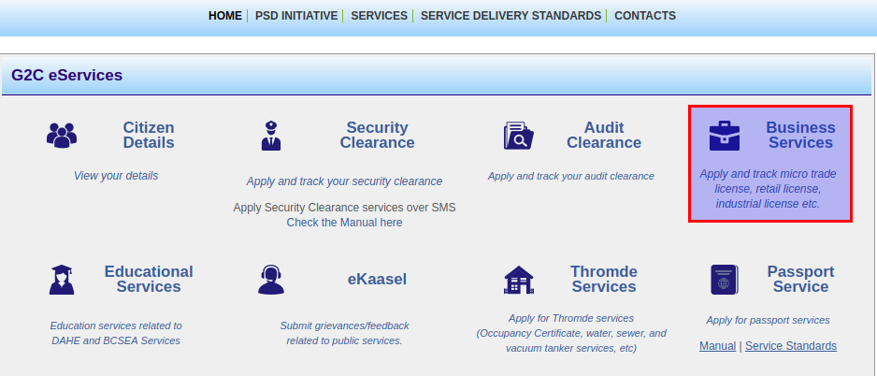

* Select application for cottage & small-scale industry license under Cottager and small industry services.

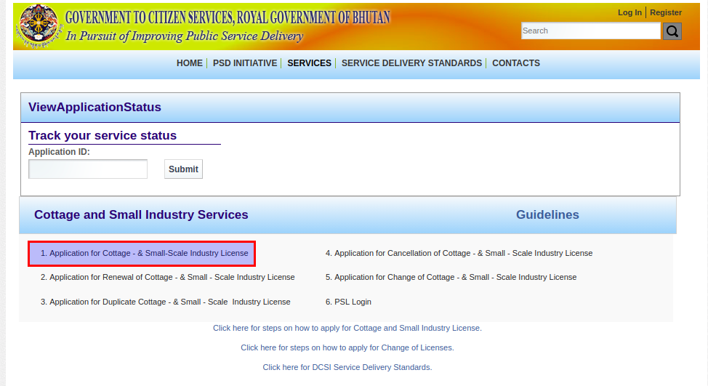

* Select ownership type and provide CID number for sole and partnership and press submit button to proceed further.

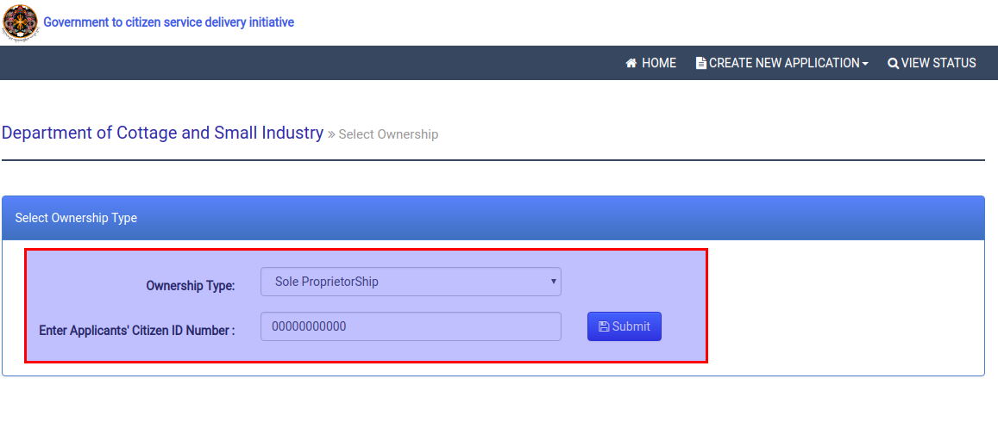

* Fill up the application form with attachments and accept the term and undertakings.

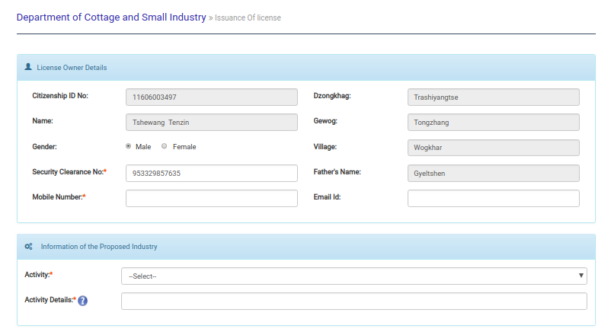

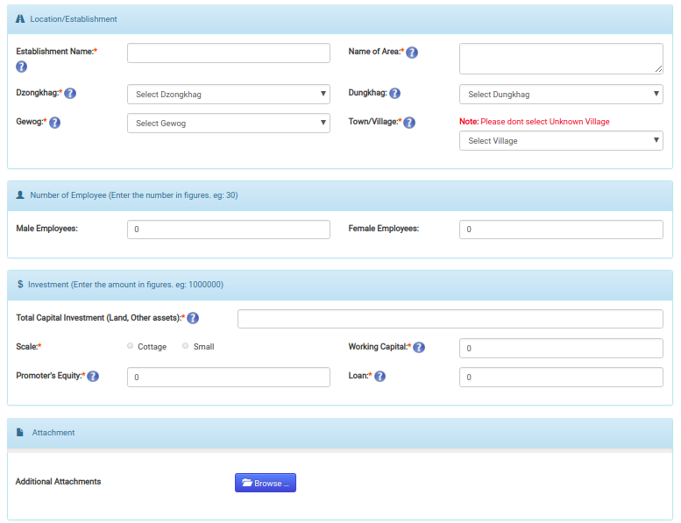

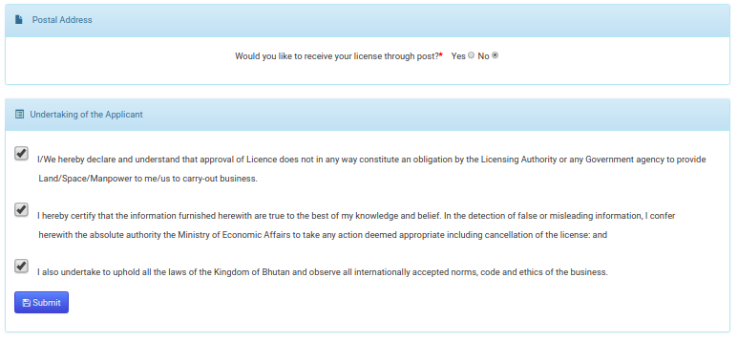

* Submits the form and will get sms submission notification with following acknowledgement.

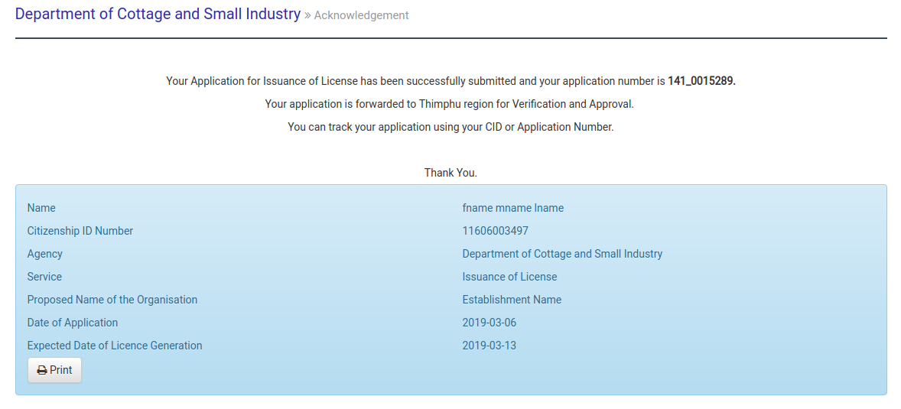

1. **Application Verification and approval.**

* Open [www.citizenservices.gov.bt](http://www.citizenservices.gov.bt) and click on log in as shown below and provide valid user credentials(username and password).

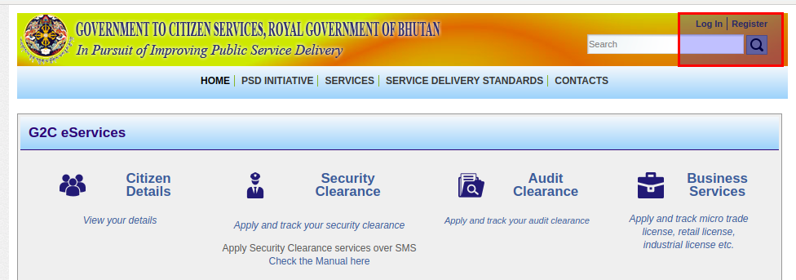

* You will be redirected to the dash board containing application list according to the role.

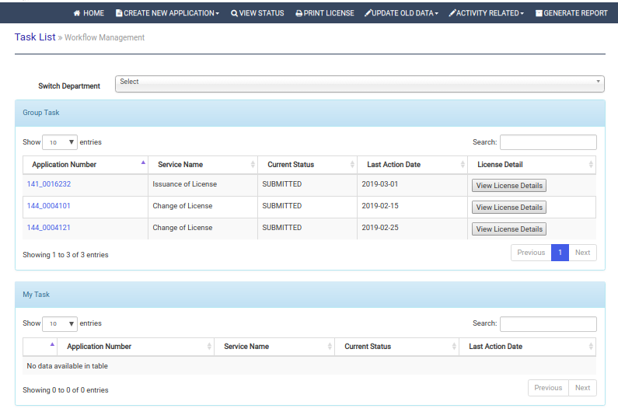

* Click on application number in group task list to claim to my task list. From my task list, again click on application number to open application. Click on red cross button form my task list to release application back to group task.

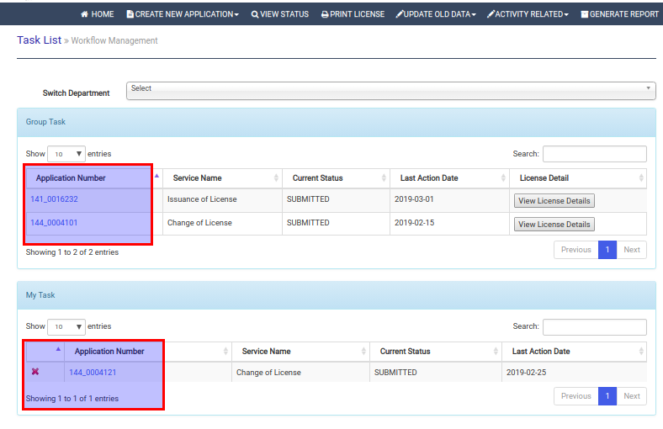

* Review and verify application details.

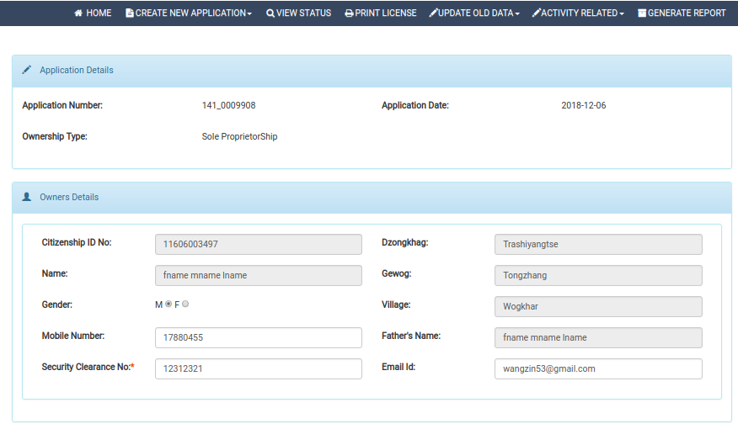

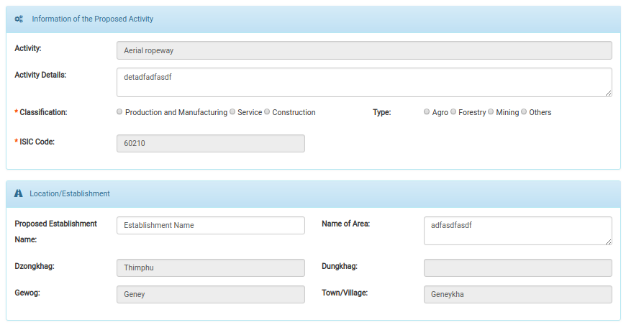 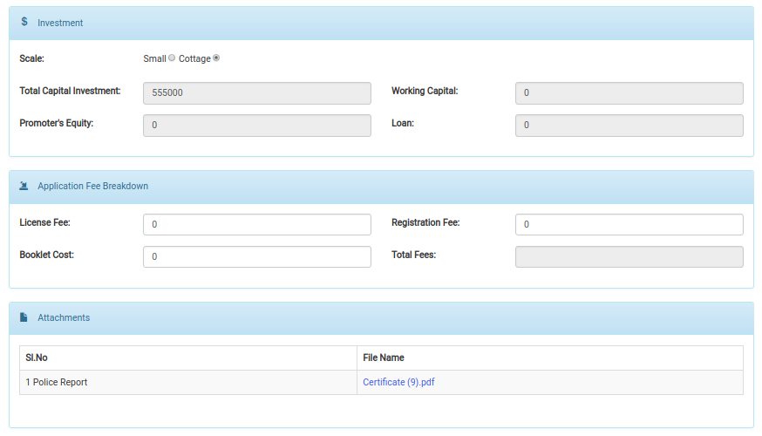

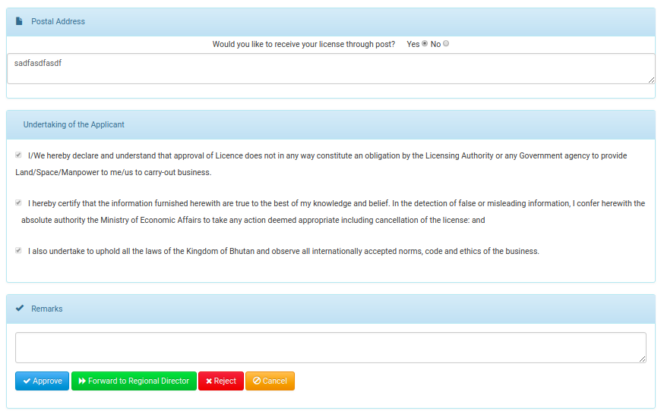

* After verification of the application details, he/she may need to take any of the action Approve/Forward to RD if he/she is data manager/Reject. He/she need to provide reason if application need to reject. Accordingly, he/she will be redirected to the acknowledgement receipt with the sms notification to applicant.

1. Approved Acknowledgement

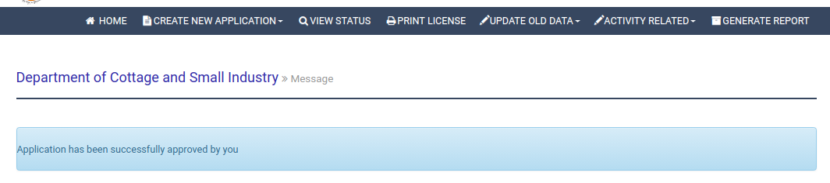

1. Reject acknowledgement

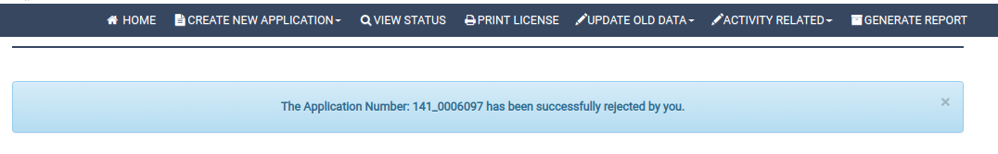

1. Forward acknowledgement

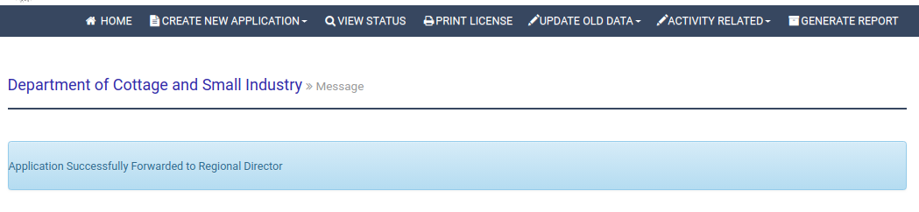

1. **Payment, Print and distribute license.**

* Applicant need to do payment for the license fees from either online or paid at RTIO. After the payment is updated, system will generated license number and now the license will be ready for printing.
* To print/update payment, Data manager should have already login to the system. He/she need to click on the link Print License from menu.

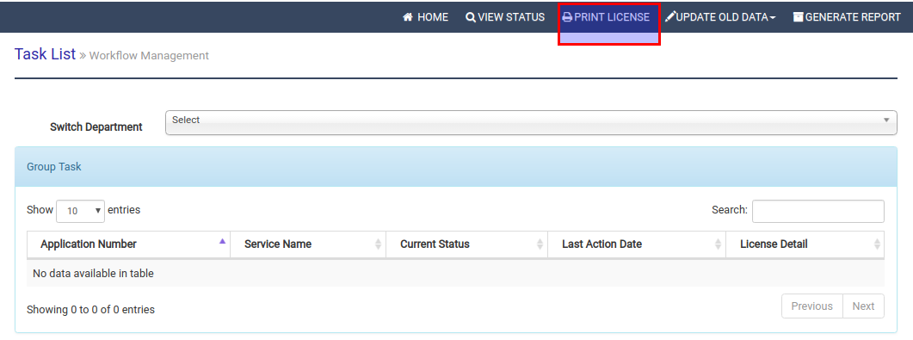

* Following modal will be pop up. If applicant is paying at RTIO, then data manager need to update the payment in system by selecting Update payment tab, other wise select print Certificate tab to print license.

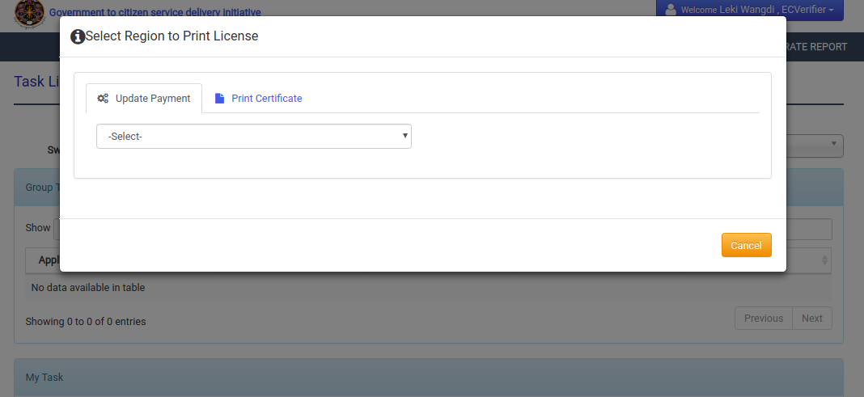

* Then data manager need to select region where the application belongs to where by the list will be displayed as follows

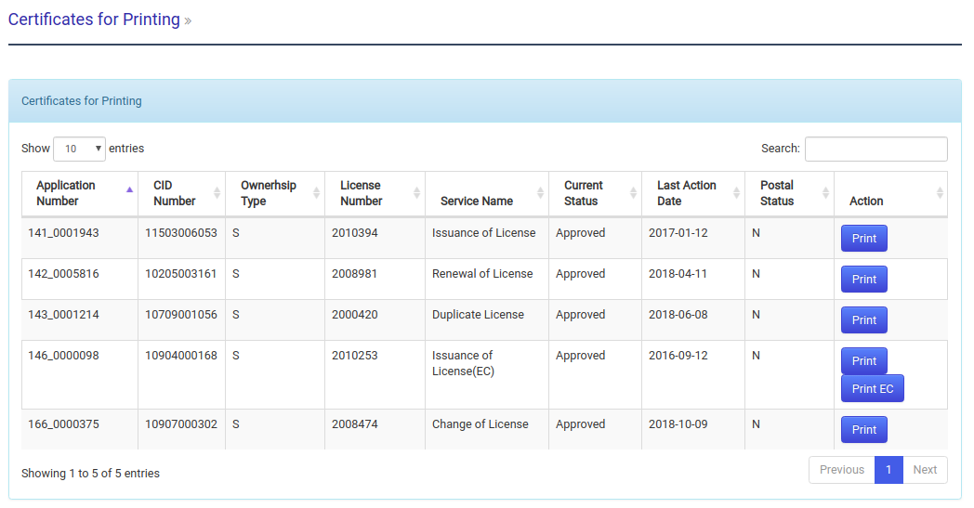

1. To update payment, there will be payment button instead of print. On clicking on payment button, following modal will get pop up to update payment details.

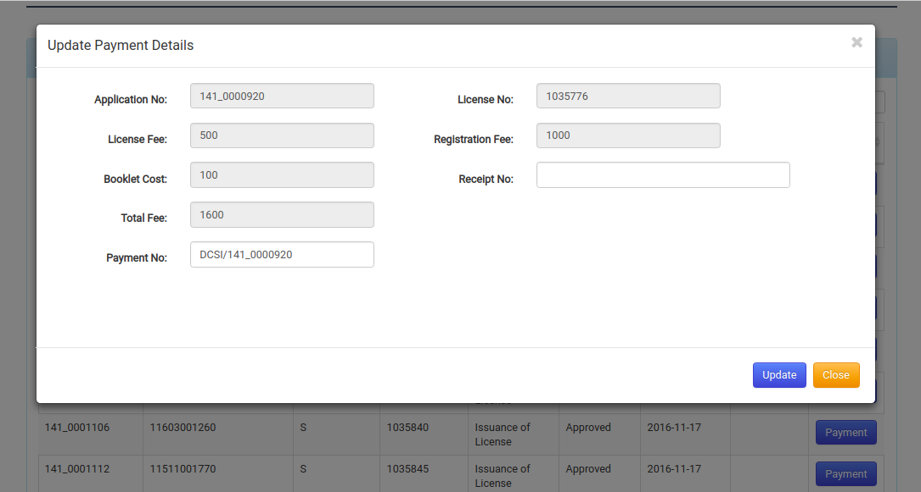

1. To print license, data manager need to click on print button form the list and license will get downloaded for printing.

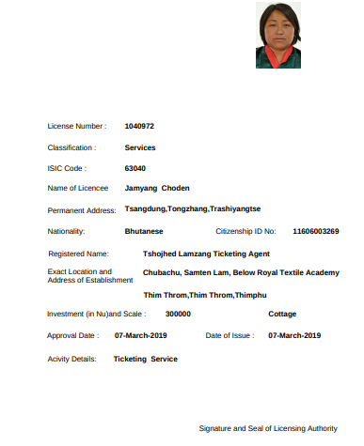

### Use Case# 3.2: Application for Renewal/Duplicate/Cancellation of cottage & small scale industry license

### 3.2.1 Description

This use case will describe the details flow of how license will be renewed online, how to cancel the existing license and how to get replacement/ produce duplicate of license with some reasons for cottage & small scale industry. The applicant needs to submit online form from any one of these there services according to his/her requirements. The applicants can also visit nearest RTIO to apply on behalf of them, if they are not aware of the online system. If the applicant visits RTIO office, then the online form will be filled up by the responsible persons and submit. User will get the acknowledgement receipt with unique Application ID and sms notification will be send to applicant. This use case translates the process described in AS-IS and TO-BE of the Process Flow Diagram.

### 3.2.2 Actor(s)

Citizens of Bhutan, Data Managers, RD.

### 3.2.3 Detailed process flow

* Applicant can visit to G2C portal to avail application for Renewal/Cancellation/Duplicate of cottage & small scale industry license.
* Click any one from the three links:
* Application for Renewal of cottage & small-scale industry license.
* Application for Cancellation of cottage & small-scale industry license.
* Application for Duplicate of cottage & small-scale industry license.

under the business services. Applicant will be redirected to the page where they need to select the ownership of existing license and need to provide CID/license number.

* System will validate for the inputs such as existence of license/CID number, provided ownership type is matching with license number, license is expired/canceled/revoked or not and others. If all are up to systems requirements, then the form will be displayed, other wise the acknowledgement with mismatch will be shown to the applicant.
* If applicant provide CID as input, then the list of license under that selected ownership type and CID will be displayed. Applicant need to select license number from that list to proceed further.
* For Renewal and Cancellation of license, applicant need to attach text clearance and other supporting documents. In addition, for cancellation of license applicant need to provide reasons. For replacement/Duplicate of license, applicant need to provide the reason and need to attach documents for that reason.
* System will generate the random Strings(application number) after applicant click on the submit button.
* Now application will be there in the Data manager (verifier) task-list for further action. Mean while applicant may check their application status from track application from the portal.
* To take further action on this application, Data manager need to login to the system. Data manager need to select the application from the group task and assign to my task and open the application for verification.
* Data manager will review the application details and verifies all the document attached along with the application. Data manager may approve or reject or forward this application to RD mentioning the application fees along with.
* If data manager rejects the application, then the applicant will receive sms notification with the reason for rejecting and if he/she approves, then applicant will again receive message with the payment information. If he/she forwards to RD, then application will be reached the the RD’s group task list.
* Data manager will then get respective acknowledgement for taking action.
* Regional director will login to the system and claim the application from group task and opens to take further action. RD may either reject or approve the application. The applicant will receive the sms notification and RD will be redirected to acknowledgement page for taking that action.
* If the application is approved form data manager or RD, then applicant need to make payment either from online payment or visiting to the RTIO(off-line payment).
* For the online payment, applicant need to visit G2C online payment from portal or he/she will be redirected from the link mentioned in sms notification. On pressing go button, system will display payment details for availing that service and need to select banks after pressing pay now button. Applicant need to have any one of the bank account with their mobile number registered with that bank. OTP will be send to the mobile of applicant if bank account and mobile are valid. Applicant needs to use OPT to pay the service fees and will be redirected to the payment receive.
* To do offline payment, applicant needs to visit RTIO with cash. Data manager will login to the system and click on print license link to update payment in the system. To do that he/she need to select update payment tab and region where the application belongs, where by the application list will be displayed and need to select that application from the list and update details.
* Once payment is done, a unique license number will be generated by system. This license will be printed from region and distributed to applicant via post or applicant can visit to RTIO office to collect themself.
* In above processes, all of the actors can track the application at any time.

**3.2.3 Alternative Flows (if any)**

* Applicant can visit to nearest RTIO to make applications for cottage & small-scale industry license.
* Data manager from RTIO will login to the system. Select one of the services listed below.
* Renewal of license.
* Issuance of license.
* Cancellation of license under Create new application.

He/She will be redirected to ‘select ownership type’ and to input applicant CID/License number.

* For sole proprietorship and partnership, he/she need to provide applicant’s CID on which the system will connect to Census database and fetch the personnel details from there.
* He/she needs to fill up rest of the details on behalf of applicant and submit the details for further approval by RD.
* System will generate the random Strings(application number) after applicant click on the submit button.
* Regional director will login to the system and claim the application from group task and opens to take further action. He/she may either reject or approve the application and accordingly the applicant will receive the sms notification and he/she will be redirected to acknowledgement page.
* Then applicant need to make payment either from online payment or visiting to the RTIO(off-line payment).
* Once payment is done, a unique license number will be generated by system. This license will be printed from region and distributed to applicant via post or applicant can visit to RTIO office to collect themself.
* In above processes, all of the actors can track the application at any time.

**3.2.4 Special Requirements (if any)**

NA.

**3.2.5 Pre Conditions**

Following are the pre- conditions to use the service –

* Scanning facility should be there at RTIO scan the required documents.
* Each RTIO needs to have a valid Login Id & Password to have access into the system.
* Applicant needs to bring the required clearances and documents.

**3.2.6 Post-Conditions**

Data manager’s task list is populated with the application submitted by applicants.

**3.2.7 Sample user interfaces**

1. **Application Submission.**

* Open [www.citizenservices.gov.bt](http://www.citizenservices.gov.bt) and click on Business Services as shown below.



* Select one services under Cottager and small industry services.

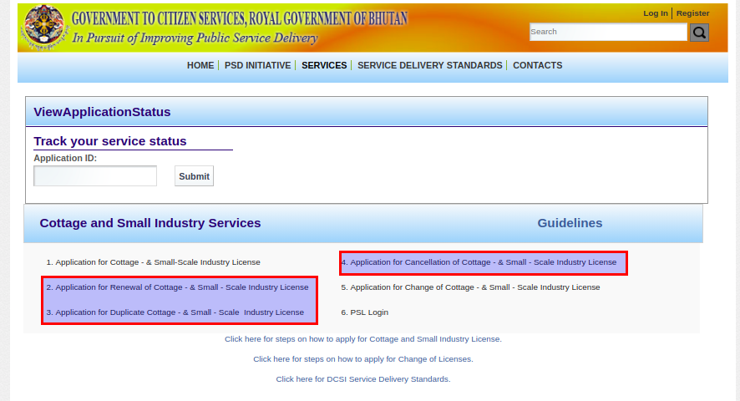

* Clicking on any of the service above, applicant will be redirected the page shown below.Below image is for renewal but similar UI will be applied for cancellation and duplicate of license.

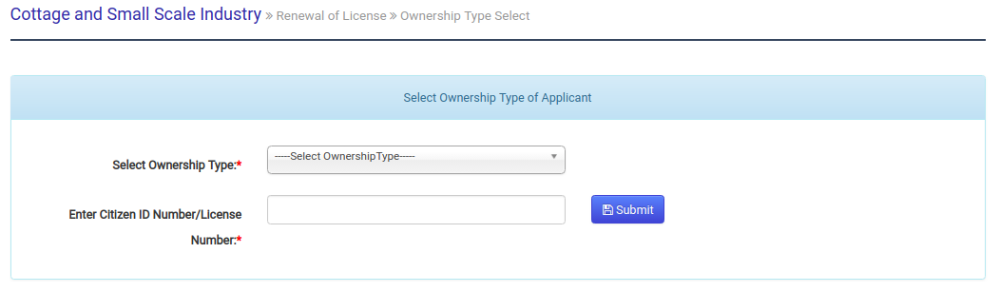

* After selecting the ownership type and providing CID/License number, applicant will be redirected to the following forms.

1. **Renewal Form**

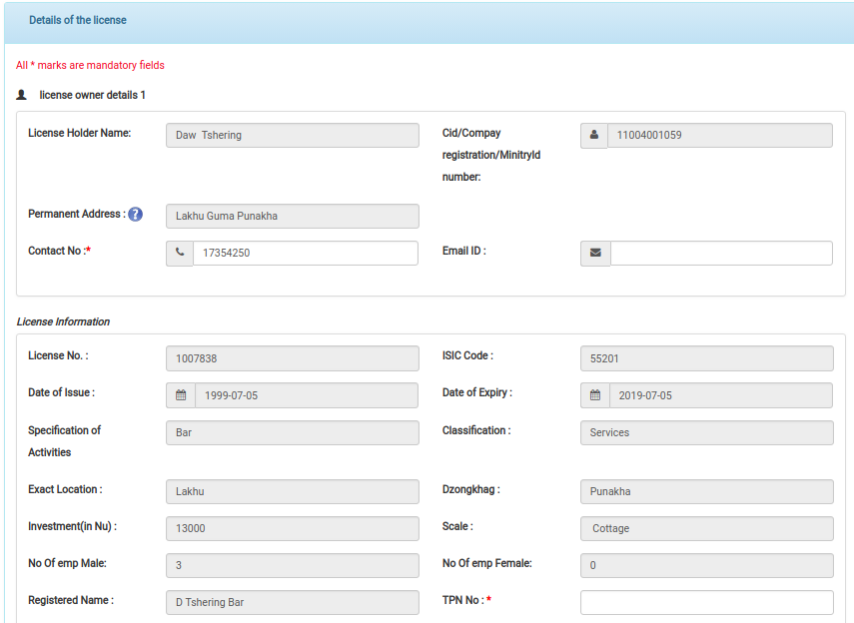

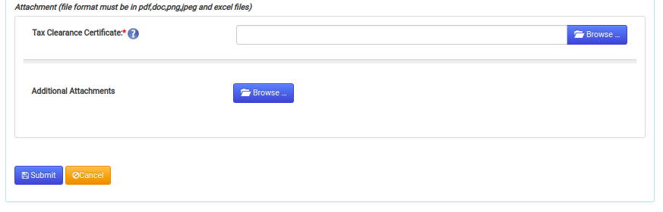

1. **Cancellation From**

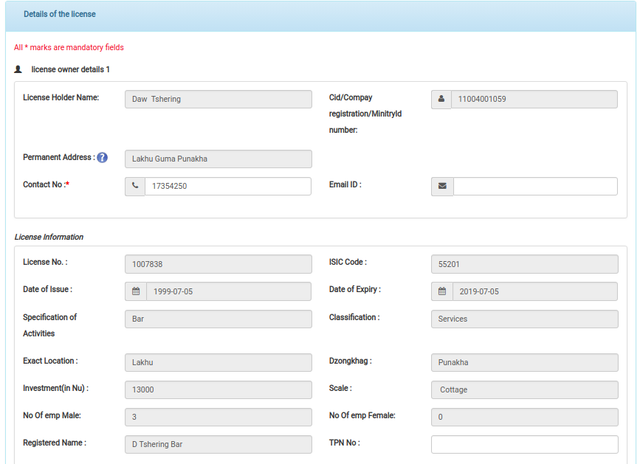

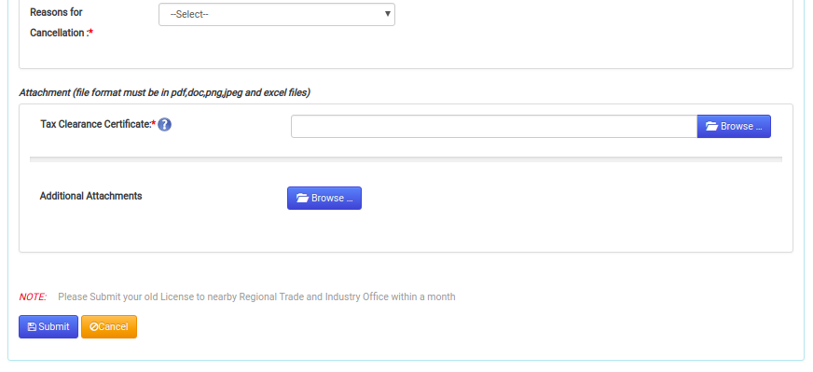

1. **Duplicate Form**

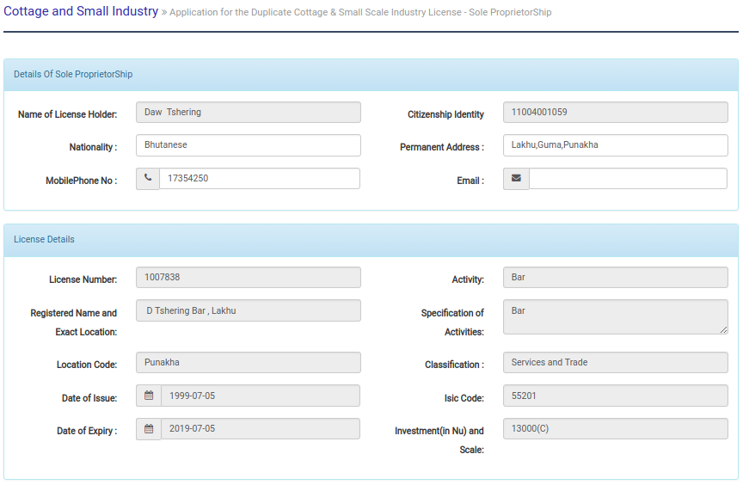

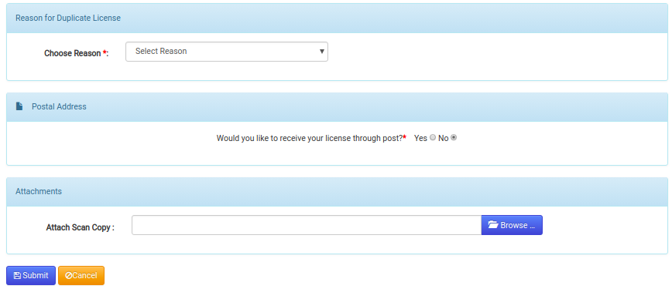

* Submits the form and will get sms submission notification with following acknowledgement. Similar acknowledgement will be displayed for cancellation and duplicate of license application.

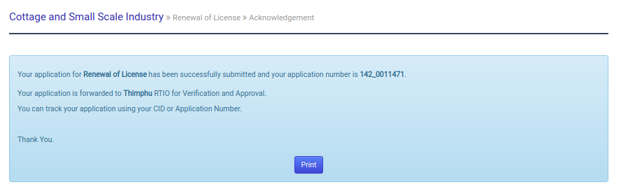

1. **Application Verification and approval.**

* Open [www.citizenservices.gov.bt](http://www.citizenservices.gov.bt) and click on log in as shown below and provide valid user credentials(username and password).



* You will be redirected to the dash board containing application list according to the role.



* Click on application number in group task list to claim to my task list. From my task list, again click on application number to open application. Click on red cross button form my task list to release application back to group task.



* Review and verify application details.

1. **Renewal verification/approval form**

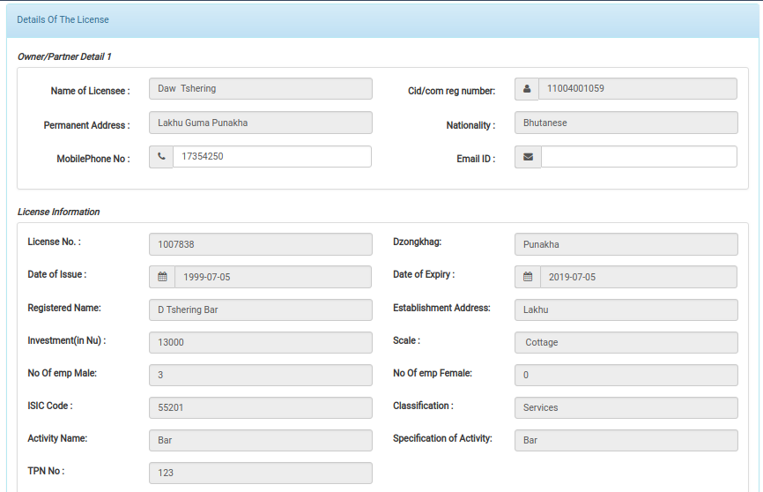

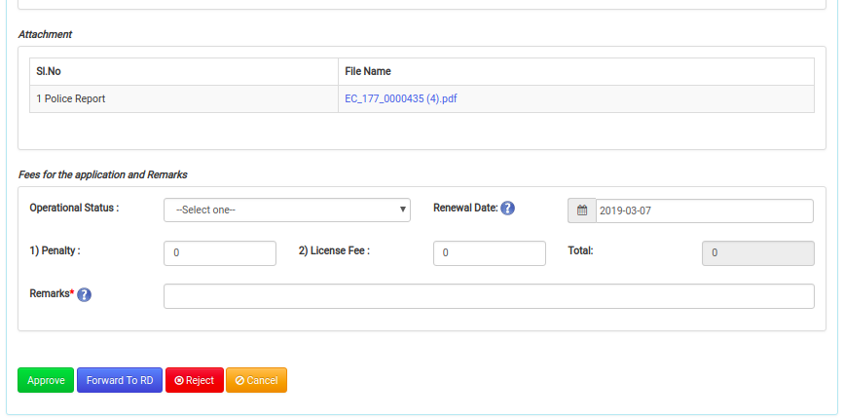

1. **Duplicate verification/approval form**

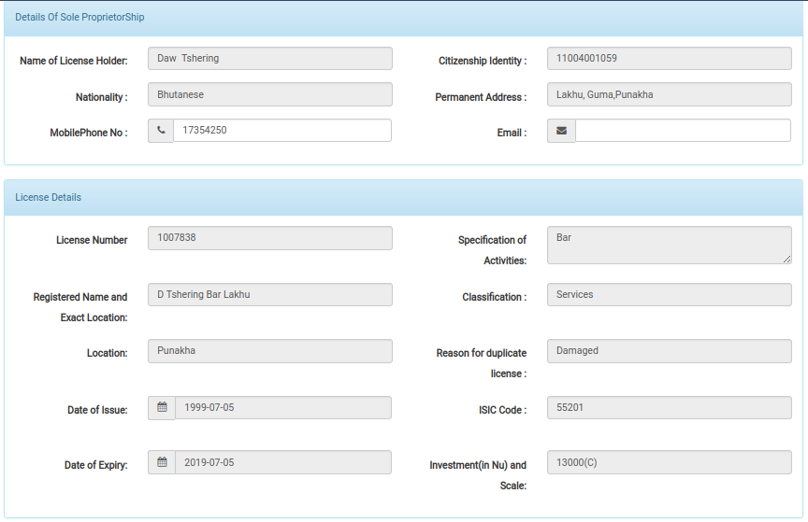

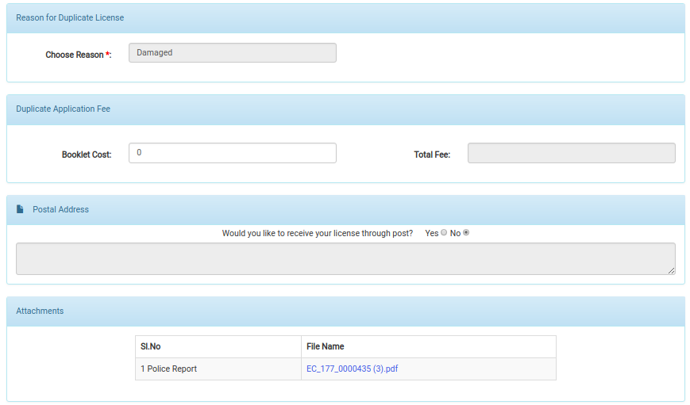

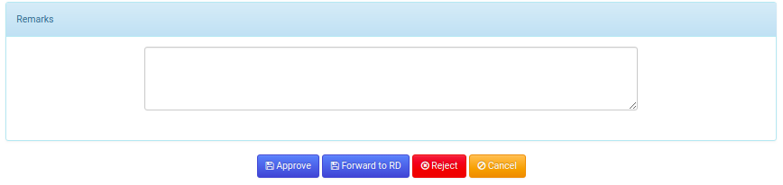

1. **Cancellation verification/approval form**

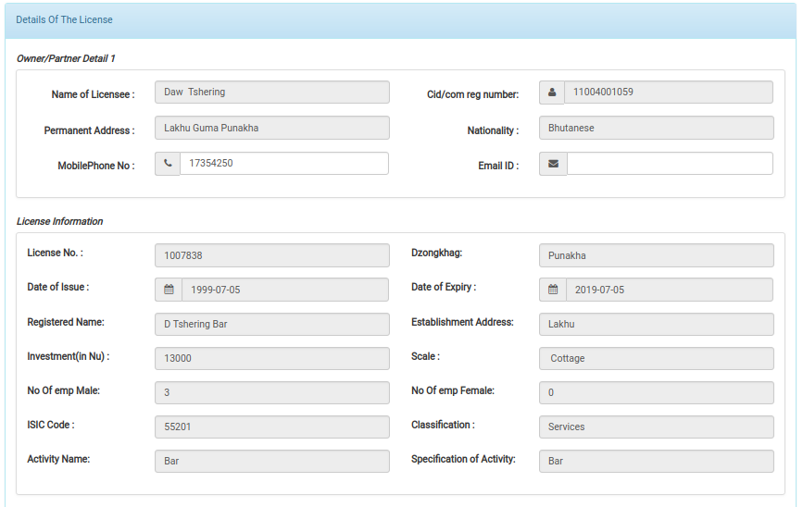

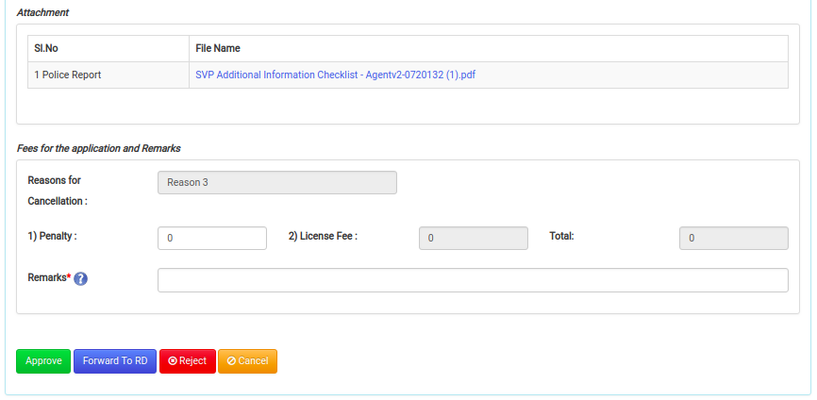

* After verification of the application details, he/she may need to take any of the action Approve/Forward to RD if he/she is data manager/Reject. He/she need to provide reason if application need to reject. Accordingly, he/she will be redirected to the acknowledgement receipt with the sms notification to applicant.

1. **Approved Acknowledgement**



1. **Reject acknowledgement**



1. **Forward acknowledgement**



1. **Payment, Print and distribute license.**

* Applicant need to do payment for the service fees from either online or paid at RTIO. After the payment is updated, system will update application for printing. There wont be printing of license in renewal and cancellation of license, this is applicable to only duplicate of license.
* To print/update payment, Data manager should have already login to the system. He/she need to click on the link Print License from menu.



* Following modal will be pop up. If applicant is paying at RTIO, then data manager need to update the payment in system by selecting Update payment tab, other wise select print Certificate tab to print license.



* Then data manager need to select region where the application belongs to where by the list will be displayed as follows



1. To update payment, there will be payment button instead of print. On clicking on payment button, following modal will get pop up to update payment details.



1. To print license, data manager need to click on print button form the list and license will get downloaded for printing.



# Reports

## 4.1 Detail Report

### Type of report

Tabular

### Purpose

The purpose of this report is to check the details of license issued.

### Frequency

As and when required.

### Search criteria/Input parameters

From date

To date.

Dzongkhag wise.

Gewog wise.

Activity wise.

### Data fields

|  |  |  |  |  |
| --- | --- | --- | --- | --- |
| Sl no | License Number | Ownership type | Name of licensee | Cid Number |
| Mobile | Telephone | Email | Issue Date | Expiry Date |
| License Cancel led | Activity Name | Isic Code | Activity Details | Scale of Investment |
| Total Investment | Classification | Sub Classification | Establishment | Exact Location |
| Renewal Date | Dzongkhag | Gewog | Village |  |

## 4.2 Figure Report

### Type of report

Numeric

### Purpose

The purpose of this report is to check the number of license issued.

### Frequency

As and when required.

### Search criteria/Input parameters

From date

To date.

Dzongkhag wise.

Gewog wise.

Activity wise.

### Data fields

Total Number of license